**Chapter 1 OBJECTIVE AND SCOPE OF THE PROJECT**

The Software deals with all the work From inserting the new employee to the employee master table to showing salary report of the employees which includes authorized login, user management, maintaining the attendance of employees, calculation of allowances and deduction along with the total salary and net salary according to the norms of the company and basic salary of the particular employee and finally show the reports based on the attendance, leave, salary etc. and at last it shows the final transaction report of employee with the company.

**Chapter 2 THEORETICAL BACKGROUND AND PROBLEM DEFINATION**

Understanding the problem in the existing system & finding requested solution is the most important activity while planning the project. Hence the developing a new system we must get through problem associated with the current system.

* In the old system, the user was maintaining the records like current leave and attendance status of the employee in the paper sheets.
* Hence it was very difficult for companies to keep track which Employee has attended how many working days and how to much to pay them.

The manpower required for this kind of transaction and maintenance of data is higher than the actual requirement.

**Chapter 3 SYSTEM ANALYSIS**

**3.1 REQUIREMENT ANALYSIS**

**3.1.1 FUNCTIONAL REQUIREMENTS**

**a) Strong Data Validation:**

There is possibility that user might enter wrong data and wrong data may cause inconsistency to the database and hence to the system. To avoid this, data should be validated whenever entered.

**b) Automatic updating of the database:**

After any transaction is performed, it is necessary that the updating should be reflected in the database without any inconsistency.

**c) Provide efficiency querying based on user requests:**

The major purpose is to generate efficient reports on any user request. This will be done by our query processing system, which should be able to process any combination of queries will be done dynamically at run time depending on the user

**3.1.2 EXTERNAL INTERFACE REQUIREMENTS**

**a) User friendly interface:**

The interface should be developed in such a manner that it is very user friendly, this not only improve interaction but also saves data entry time.

**b) Making well designed forms for capturing data:**

The forms for capturing the data should be well-designed using pop-down menus and drag & drop facilities, which reduce the data entry effort on the part of the user.

**3.1.3 PERFORMANCE REQUIREMENTS**

**a) Security:**

All users are not allowed to access the database. Hence there is a need to check authority of every user. Username and Password validation helps to deny unauthorized access to the system.

There are two types of user

1) Administrator :- Who can perform all the task Read Write and Update.

2) User :- Who cannot take part in salary generation and updates.

**3.2 ERD**

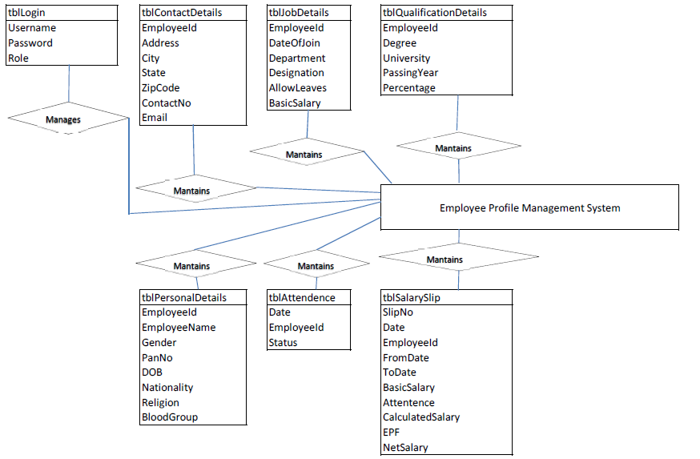

* 1. **DATA FLOW DIAGRAM** User

Add User

Details User Details

Admin

Salary Slip

Salary Salary Slip Repord

Details

Admin/User

Add Employee Detail

Employee Employee Record

Details

Add Attendants

Details

Attendants Attendants Record

Details

Add Salary Details

Salary Salary Slip Record

Details

* 1. **CONTEXT LEVEL DAIGRAM**

Employee

6. Employee Details

Admin/User

5.Salary Slip Details

4.Attendants Details

3.Salary Details

2. Employee Details

1.Login

* 1. **Methodology adopted, system implementation and details of hardware and software used**

**3.5.1 PROCESS MODEL – SOFTWARE ENGINEERING**

In the development of software we have used **Waterfall Model**, the linear sequential mode. This model encompasses the following activities:

**a) Analysis Phase:**

System Analysis:-

This refers to the gathering of system requirements, with the goal of determining how these requirements will be accommodated in the system.

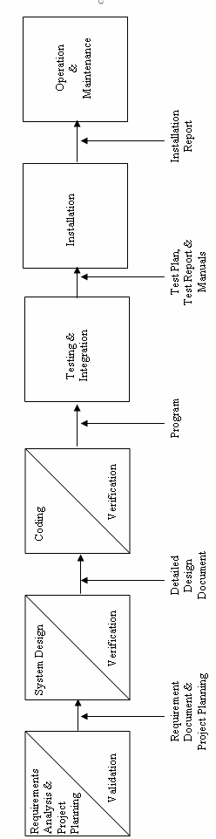

**b) System Design Phase:**

This is actually a multistep process. In this we tried to focus on some distinct attributes of a program like data structure, software architecture, interface representations and algorithmic detail. In this we tried to translate requirements into representation of the software which can be assessed for quality before coding begins. In the verifications, I have tried to ensure that the design is satisfying the requirements and is of good quality. I have tried to find out if there is any misinterpretation of specified any requirements.

**c) Code Generation Phase:**

In this phase, we translated design of a system into code which can be compiled and executed. In this phase we have done actual coding for all forms. In this we tried to produce simple program which are clear to understanding and modify.

We have used dynamic method to verify the code. We have executed program on some test data and output of the program examined to determine if there are any error present. I have read the code carefully to detect any discrepancies between the design specification and the actual implementation.

**d) Testing:**

Testing plays a critical role in quality assurance for software. Due to limitations of the verification methods for the previous phase, design and requirement faults also appear in the code. Testing is used to detect these errors, in addition to the errors introduced during the coding phase.

# 3.5.2 TOOLS/ENVIRONMENT USED

# SOFTWARE / HARDWARE REQUIREMENTS SPECIFICATION

**PLATFORM:**  Windows XP Professional

**FRONT END:** Visual Studio 2008.

**BACK END:** SQL Server 2008

**HARDWARE REQUIREMENTS:**

Intel Pentium III 733 MHz or Higher.

256 MB RAM or Higher.

**3.5.3 SYSTEM DESIGN**

# DATA STRUCTURE

**1) Table Name: tblLogin**

|  |  |  |  |
| --- | --- | --- | --- |
| **FIELD** | **SIZE** | **TYPE** | **DESCRIPTION** |
| Username | 50 | varchar(50) | Username |
| Password | 50 | varchar(50) | Password |
| Role | 50 | varchar(50) | Role(Administrator/User) |

**2) Table Name: tblAttendence**

|  |  |  |  |
| --- | --- | --- | --- |
| **FIELD** | **SIZE** | **TYPE** | **DESCRIPTION** |
| Date |  | date | Date |
| EmployeeId | 50 | varchar(50) | Employee Id |
| Status | 50 | varchar(50) | Present/Absent |

**3) Table Name: tblAttendence**

|  |  |  |  |
| --- | --- | --- | --- |
| **FIELD** | **SIZE** | **TYPE** | **DESCRIPTION** |
| EmployeeId | 50 | varchar(50) | Employee ID |
| Address |  | varchar(MAX) | Residential Address |
| City | 50 | varchar(50) | City |
| State | 50 | varchar(50) | State |
| ZipCode | 50 | varchar(50) | Zip Code |
| ContactNo | 50 | varchar(50) | Contact Number |
| Email | 50 | varchar(50) | Email Address |

**4) Table Name: tblJobDetails**

|  |  |  |  |
| --- | --- | --- | --- |
| **FIELD** | **SIZE** | **TYPE** | **DESCRIPTION** |
| EmployeeId | 50 | varchar(50) | Employee ID |
| DateOfJoin |  | varchar(MAX) | Date of joining |
| Department | 50 | varchar(50) | Department |
| Designation | 50 | varchar(50) | Designation |
| AllowLeaves | 50 | varchar(50) | Allowed Leaves |
| BasicSalary | 50 | varchar(50) | Basic Salary |

**5) Table Name: tblPersonalDetails**

|  |  |  |  |
| --- | --- | --- | --- |
| **FIELD** | **SIZE** | **TYPE** | **DESCRIPTION** |
| EmployeeId | 50 | varchar(50) | Employee ID |
| EmployeeName | 50 | varchar(50) | Employee Name |
| Gender | 50 | varchar(50) | Gender |
| PanNo | 50 | varchar(50) | PAN Card No. |
| DOB |  | date | Date Of Birth |
| Nationality | 50 | varchar(50) | Nationality |
| Religion | 50 | varchar(50) | Religion |
| BloodGroup | 50 | varchar(50) | Blood Group |

**6) Table Name: tblQualificationDetails**

|  |  |  |  |
| --- | --- | --- | --- |
| **FIELD** | **SIZE** | **TYPE** | **DESCRIPTION** |
| EmployeeId | 50 | varchar(50) | Employee ID |
| Degree | 50 | varchar(50) | Degree |
| University | 50 | varchar(50) | Name of University |
| PassingYear | 50 | varchar(50) | Year Of Passing |
| Percentage | 50 | varchar(50) | Percentage in Last Year |

**7) Table Name: tblSalarySlip**

|  |  |  |  |
| --- | --- | --- | --- |
| **FIELD** | **SIZE** | **TYPE** | **DESCRIPTION** |
| SlipNo | 50 | varchar(50) | Slip Number |
| Date |  | date | Date of issue |
| EmployeeId | 50 | varchar(50) | Employee ID |
| FromDate |  | date | From date |
| ToDate |  | date | To date |
| BasicSalary | 50 | varchar(50) | Basic Salary |
| Attentence | 50 | varchar(50) | Number of days Attended |
| CalculatedSalary | 50 | varchar(50) | Salary as per Attendance |
| EPF | 50 | varchar(50) | EPF Duduction |
| NetSalary | 50 | varchar(50) | Net Salary Paid |

**3.5.4 TESTING**

Software testing is a critical element of software quality assurance and represents the ultimate review of specification, design, coding.

**Testing objectives**

1. Testing is a process of executing a program with the intent of finding an error.

2. A good test case is the one that has high portability of finding an as-yet undiscovered error.

3. A successful test is one that uncovers an as-yet discovered error.

The main objective here will be to design test cases to uncover different classes of errors and to do so with minimum amount of time and efforts. If testing is conducted successfully it will uncover errors in the software. Another advantage is that it demonstrates that software functions appear to be working according to the specifications and performance requirement have been met.

But Testing cannot show the absence of defects it can show only that software errors are present.

**Strategies used for software testing**

The software engineering process is viewed as spiral as shown:

**Unit testing** begins at the vortex of the spiral and concentrates at the each unit of the software as implemented in the source code. Unit testing assures each module tested individually functions properly as a unit.

**Integration testing** focuses on the design and construction of the software architecture. It is a systematic technique for constructing a program structure while conducting tests to uncover errors associated with interfacing. The objective is to take unit-tested module and build a program structure that has been specified as design.

**Validation testing** takes care of the requirements established as part of the software requirements analysis are validated against the software that has been constructed. It is said to be successful when the software functions in a manner that can be reasonably expected by the customer.

**System testing** tests software and other system elements as a whole. These tests fall outside the scope of software engineering process and are not conducted solely by the software developer.

**3.5.5 DATA MODULES AND THEIR DESCRIPTION**

**1) Login:**

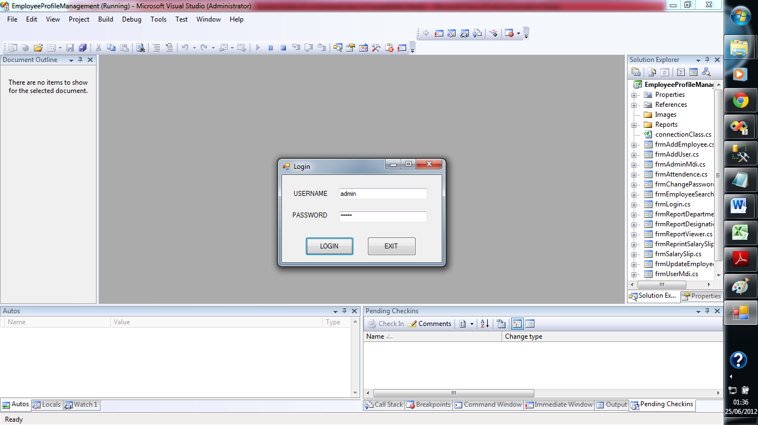

**2) Administrator Home:**

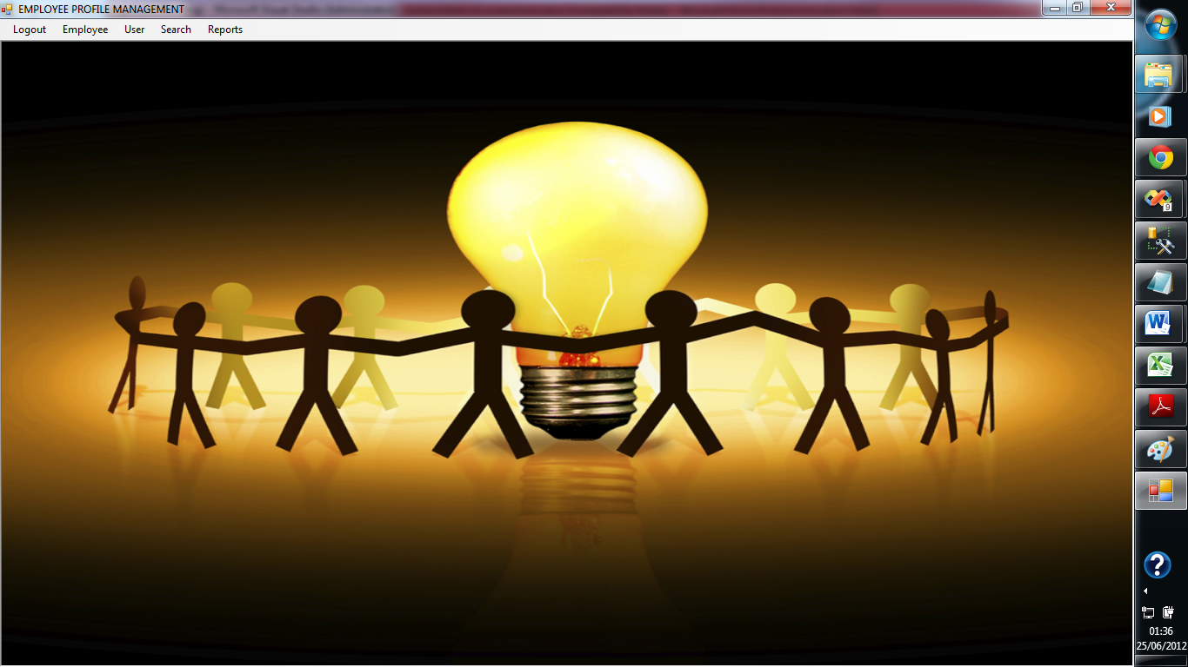

**3) Add Employee Personal Details:**

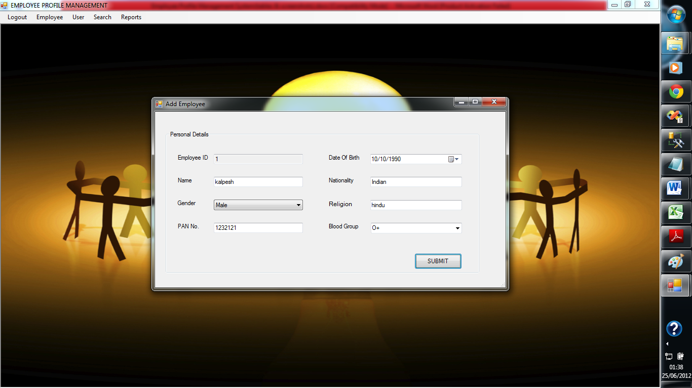

**4) Add Employee Contact Details:**

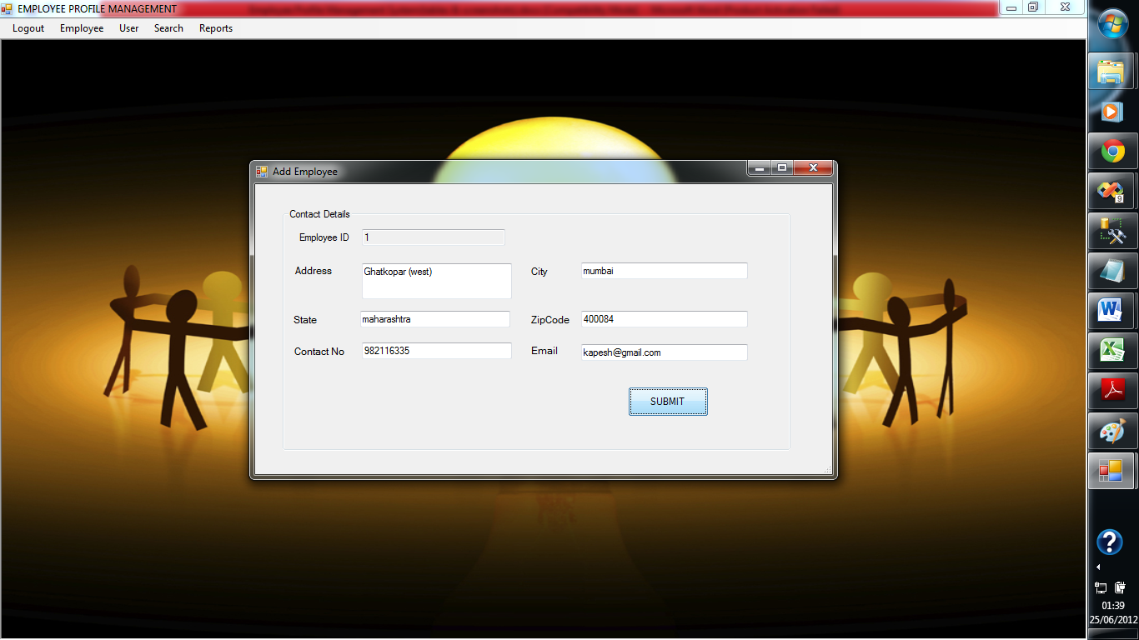

**5) Add Employee Qualification Details:**

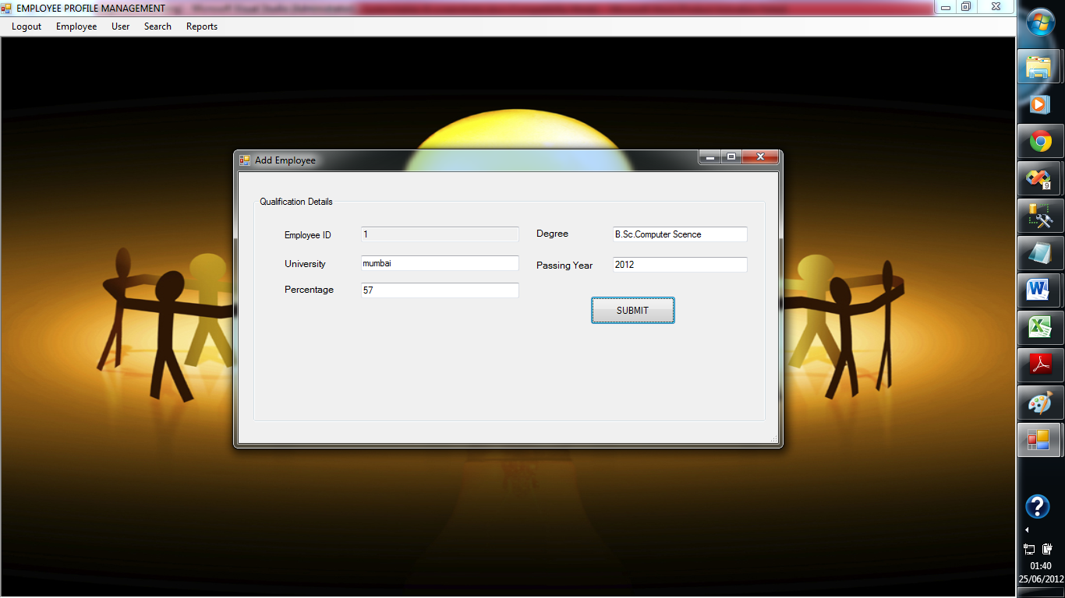

**6)Add Employee Job Details:**

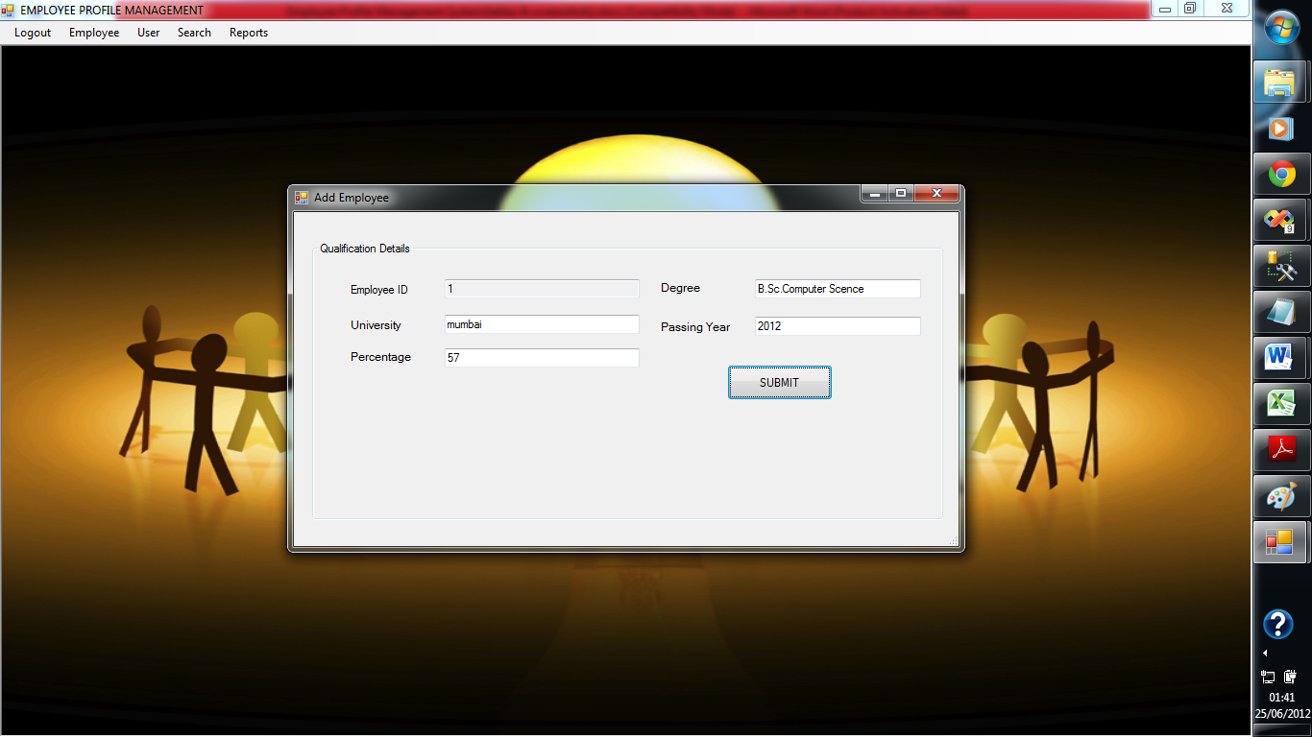

**7) Update Employee:**

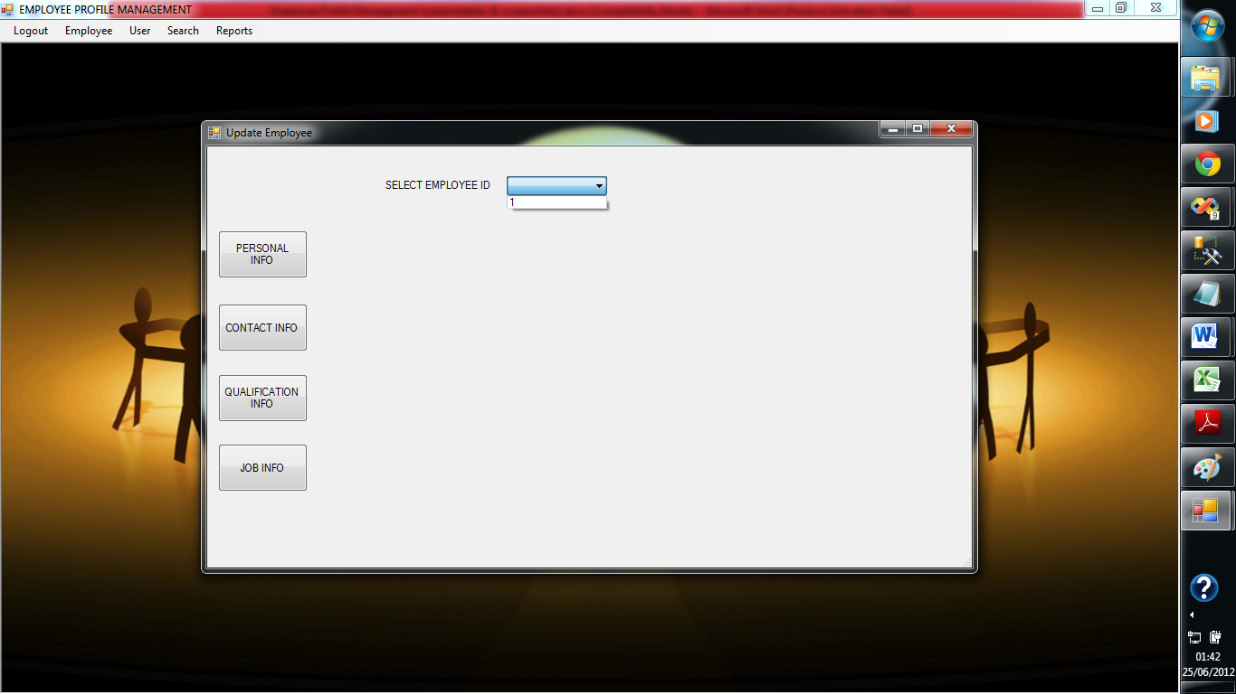

**8) Update Employee Personal Details:**

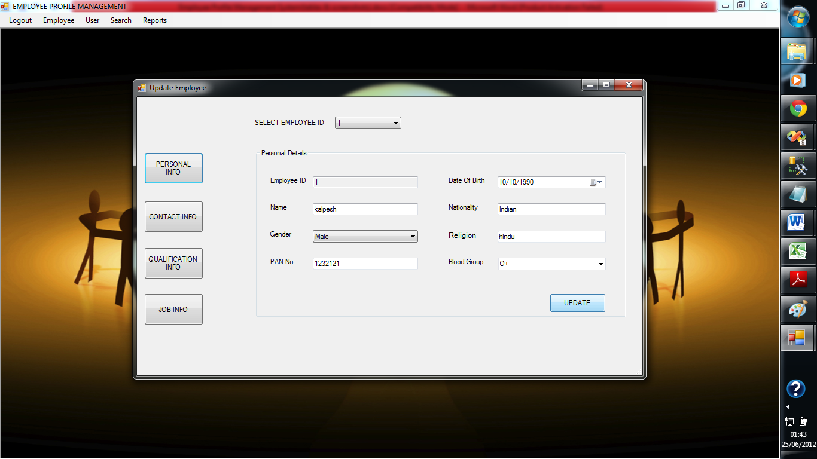

**9) Update Employee Contact Details:**

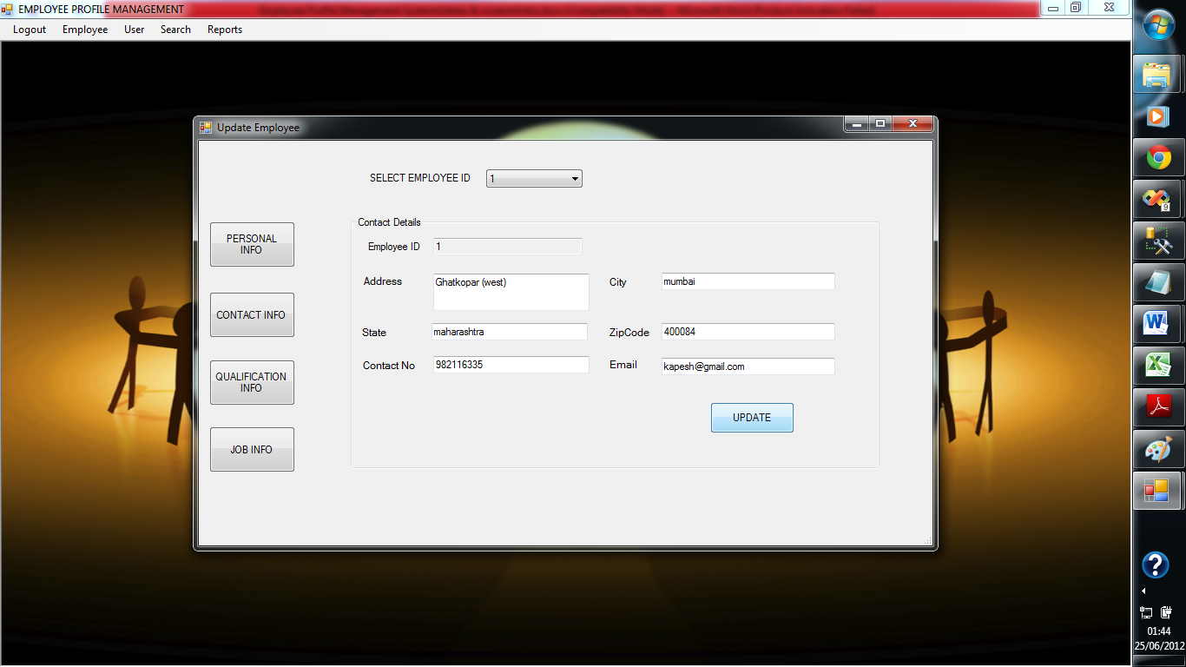

**10) Update Employee Qualification Details:**

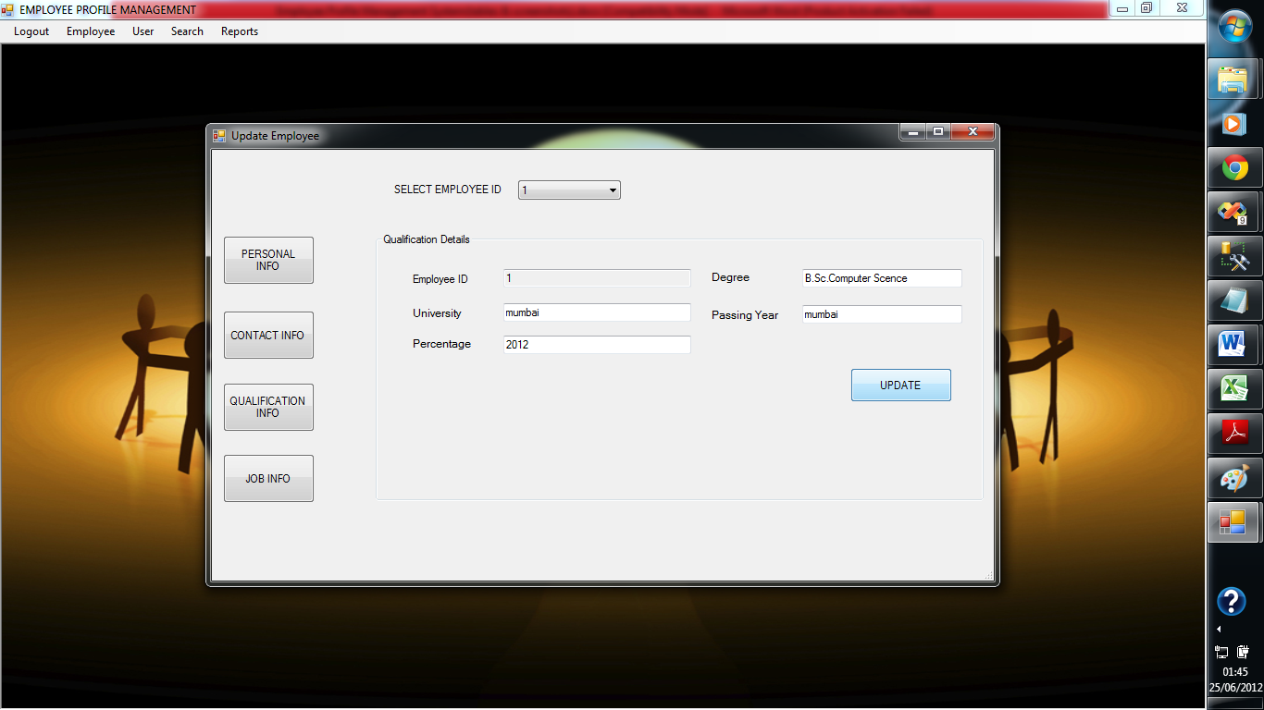

**11) Update Employee Job Details:**

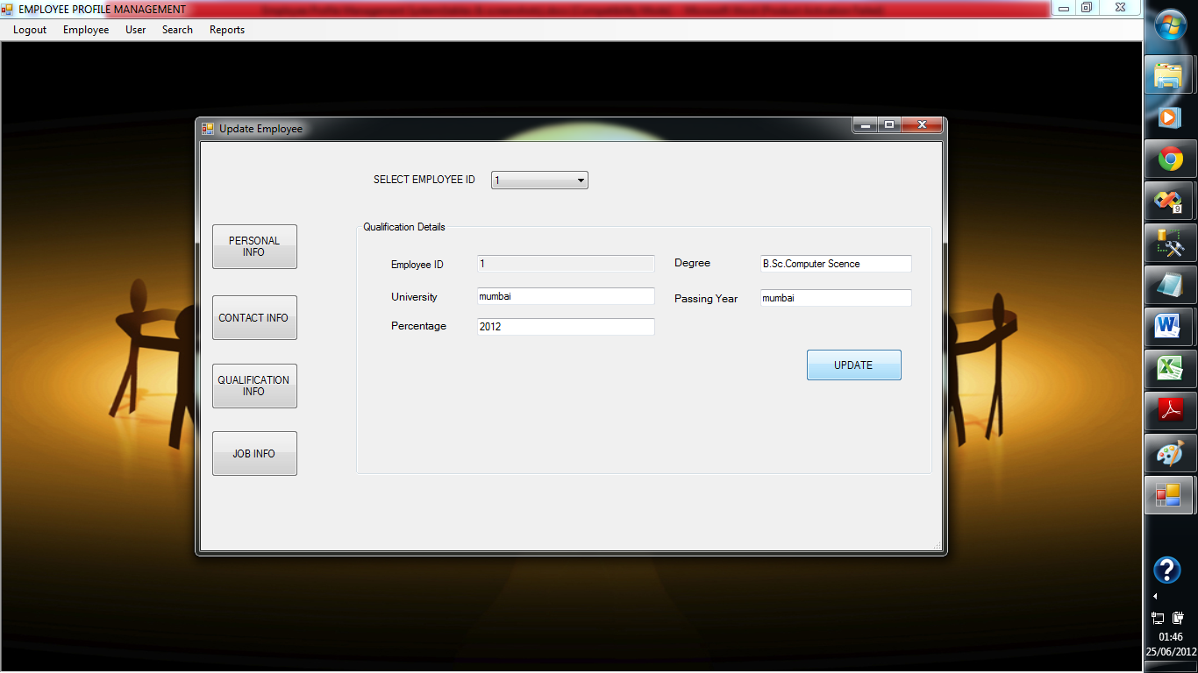

**12) Search Employee:**

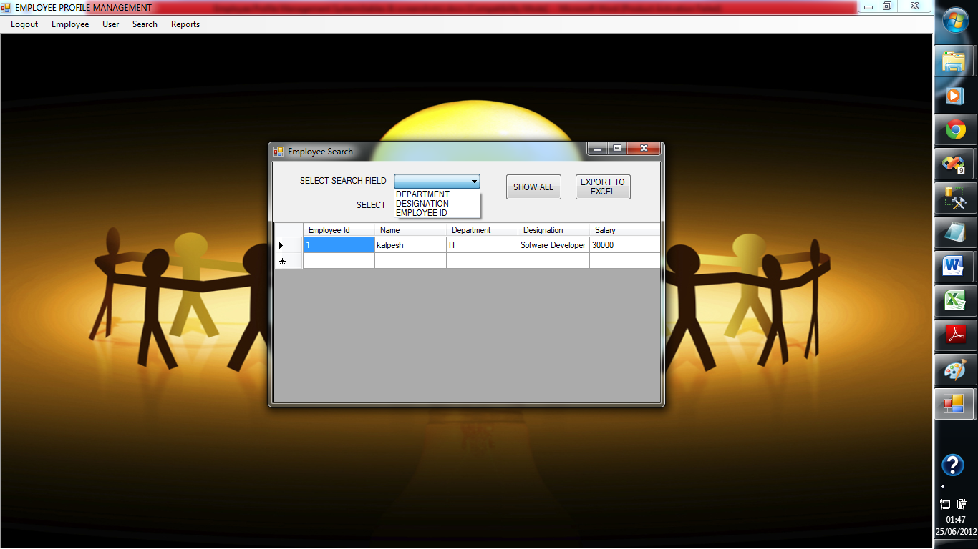

**13) Attendance**

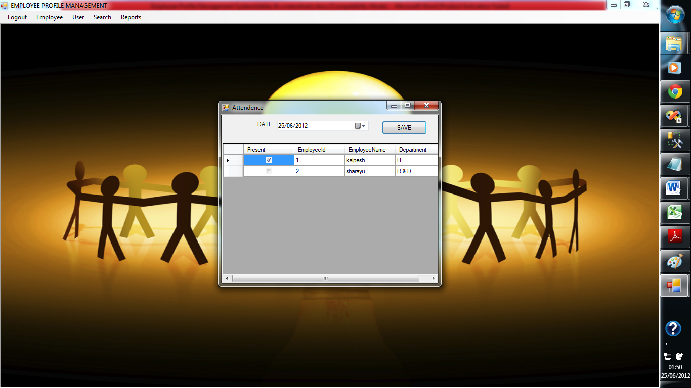

**14) Salary Slip:**

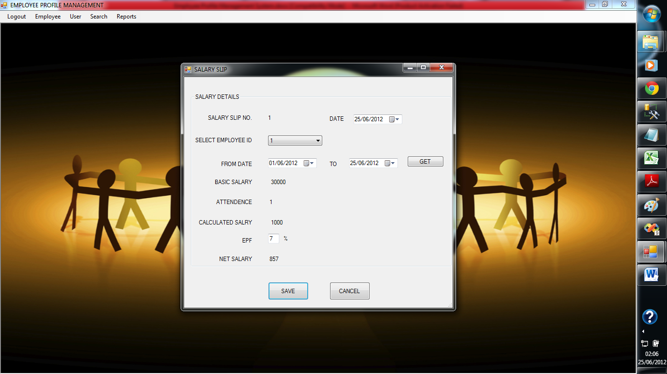

**15) Create User:**

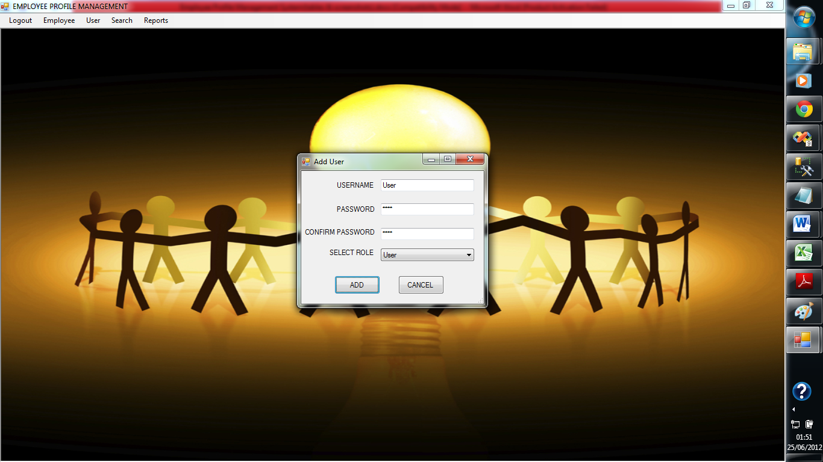

**16) Change Password:**

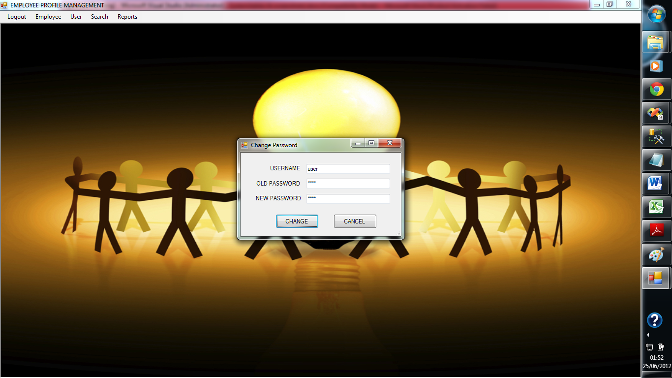

**17) Reports:**

